Tatton Wildlife Newsletter – Winter
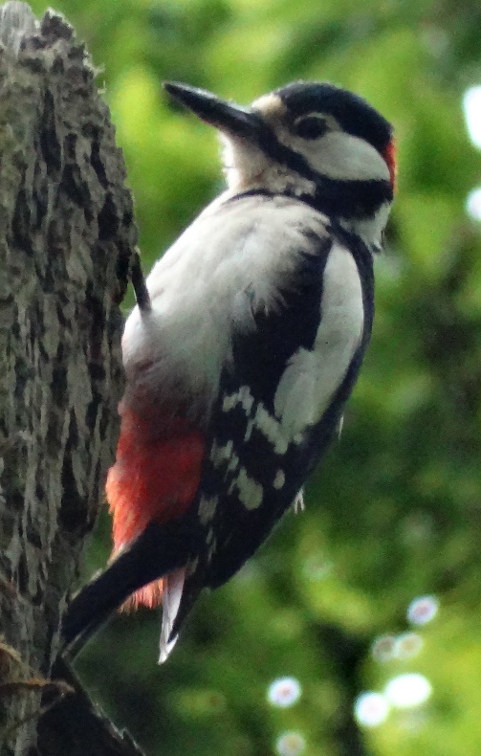
Winter is an excellent time to get out and enjoy the wonderful views and wildlife that Tatton has to offer. It has been proven that open spaces and exercise, especially near to water, improve our mental health and wellbeing. Now is the time to make the most of the shorter daylight hours and to explore the beautiful parkland.
Deer
Now that the rut has ended the deer will again group together. As we move into winter, there is still grass available on the parkland. Even so, by mid-November the deer are always fed daily. It is known that deer will not gain any condition after Christmas, therefore getting them used to coming to the feed and improving their post-rut condition is vital for them at this time. As the season progresses the grass will diminish, and they become more reliant on the feed. They are fed carrots and cattle nuts. If the weather is particularly cold, they also get fed haylage. We try to rotate the areas where we feed the deer to encourage them to forage for themselves and not become lazy just waiting to be fed! It also prevents damage to the ground in wetter weather.

Birds
Our summer visitors have now left for sunnier climes, the last swallow was seen on the 13/10. The day before, the first redwing, a winter visitor from Scandinavia arrived here and across the country, a massive influx of redwings and fieldfares occurred on the 19/10. This “vis-mig” (visible migration) was noted at the Mill Pool where the hawthorn trees were full of them as they gorged on the berries.
Back in February 2021 a rare North American visitor, a hooded merganser, was found on Melchett Mere. The origin of this bird was not known or whether it had maybe escaped from a collection, but after careful consideration by the British Birds Rarities Committee, it has been accepted as the 13th record for the UK and a first for Cheshire and Wirral. Unfortunately, few people had chance to view the bird as the nation was under Covid restrictions at the time.
Winter is the time to see wildfowl on the meres as numbers increase during this season. Now is the time to find woodland birds too as they flock together and are easier to see. Beech Avenue is a good place to look for bramblings as they like to feed on beech mast. The coniferous woodlands are the place to see siskins and redpolls, this habitat is favoured by goldcrests too which may be joined by its rarer cousin, the firecrest.
Woodland
Woodlands have climates of their own and, the larger the wood, the more sheltered are its depths providing refuge for many plants and animals against hard frosts and drying winds. The warm, damp microclimates found behind flaking bark or in decaying holes support beetle larvae, spiders, and woodlice - a valuable food source for many woodland birds including nuthatches and woodpeckers (Pictured)
The carpets of leaf litter that cover the woodland floor are also a fertile layer that provide food and habitat for many forms of life and are especially important in winter. Some butterfly species stay with us all year round and, dependant on species, overwinter in their egg, caterpillar, pupal or adult form. The leaf litter provides a perfect place for them to remain concealed until spring.
We are very lucky to have some magnificent woodlands and specimen ancient trees here at Tatton and winter is a fantastic season to enjoy them.

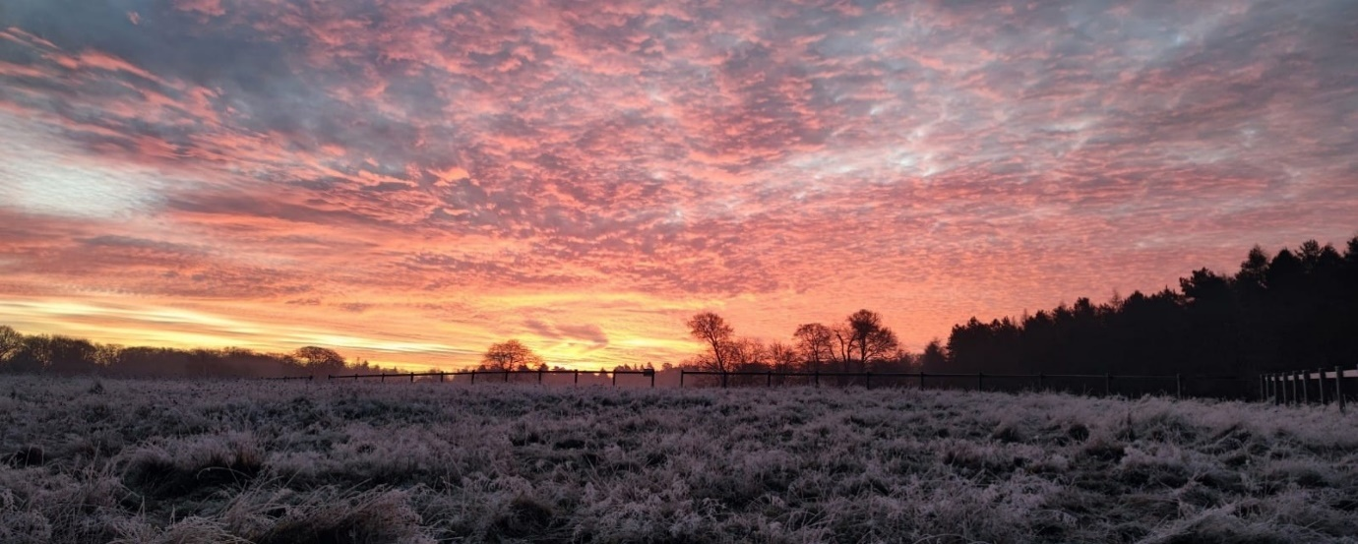
Compiled by Tatton’s Ranger Team

